SYSTEM DESIGN
Data Flow Diagram / Use Case Diagram / Flow Diagram
The DFD is also called as bubble chart. It is a simple graphical formalism that can be used to represent a system in terms of the input data to the system, various processing carried out on these data, and the output data is generated by the system.
Data Flow Diagram:
(User)

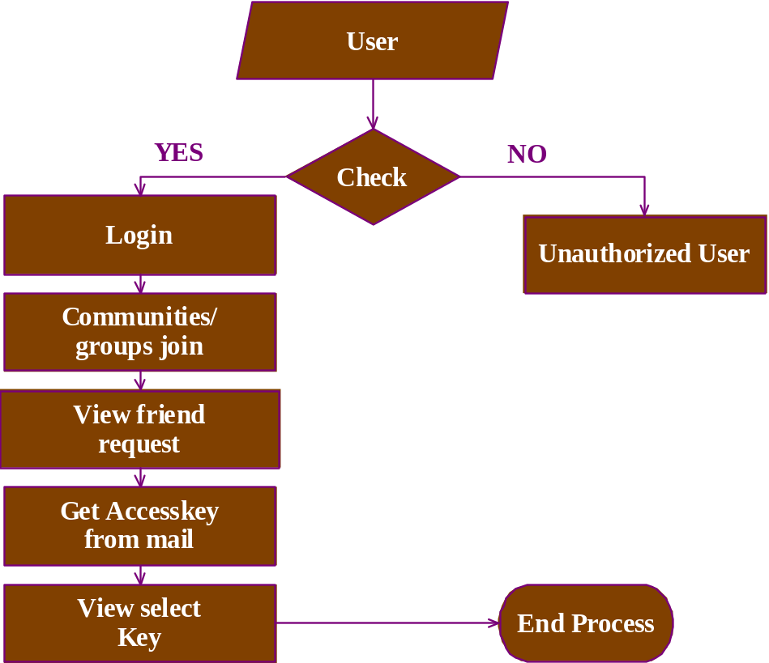

Admin:
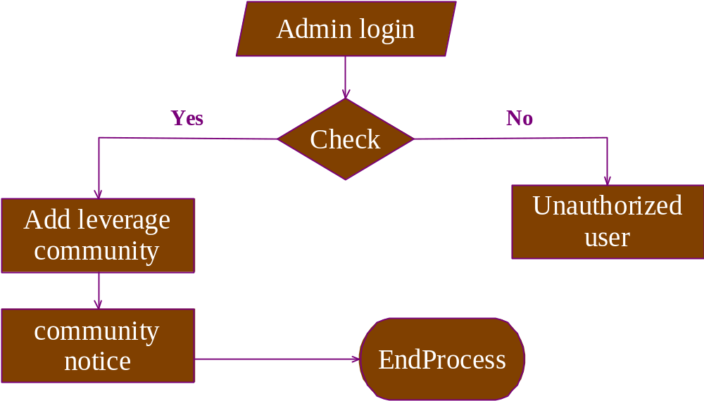

(Community ):

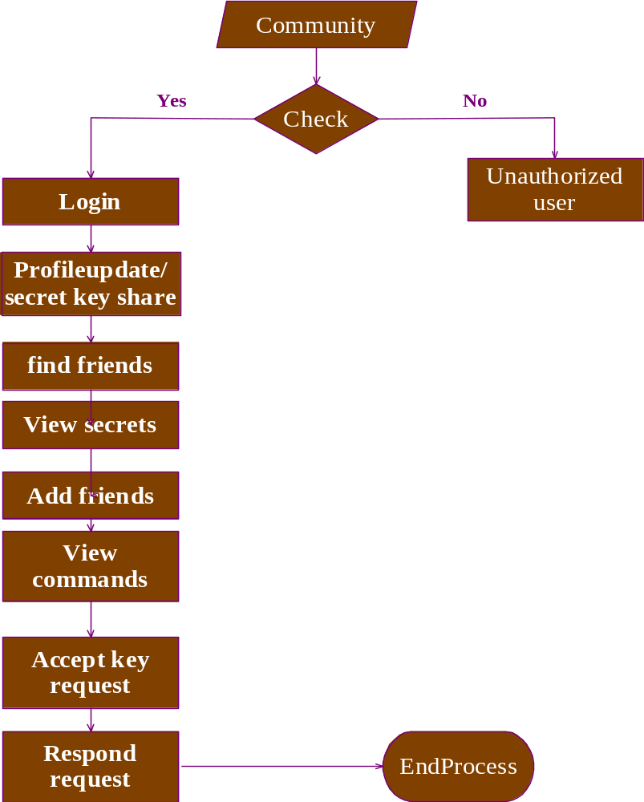

Group:
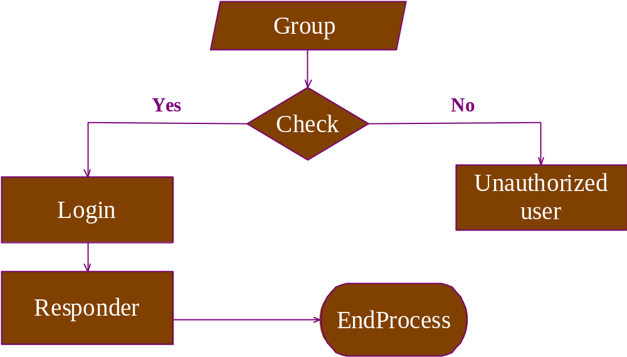

Component Diagram:

(User):
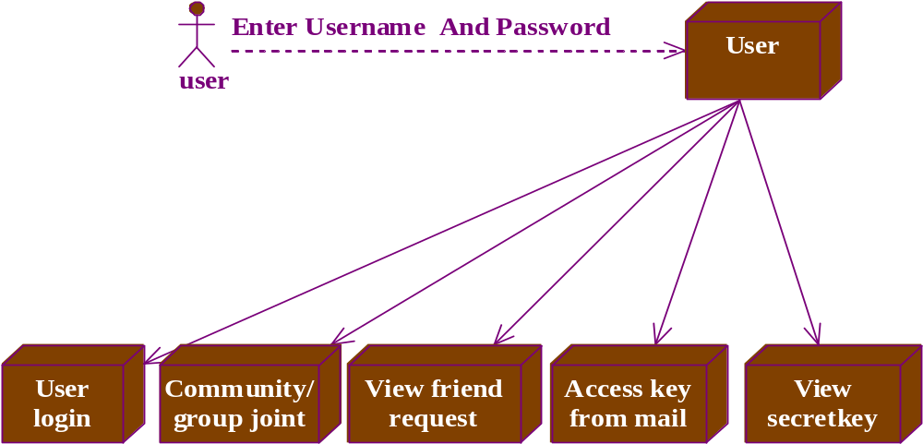

(Community)

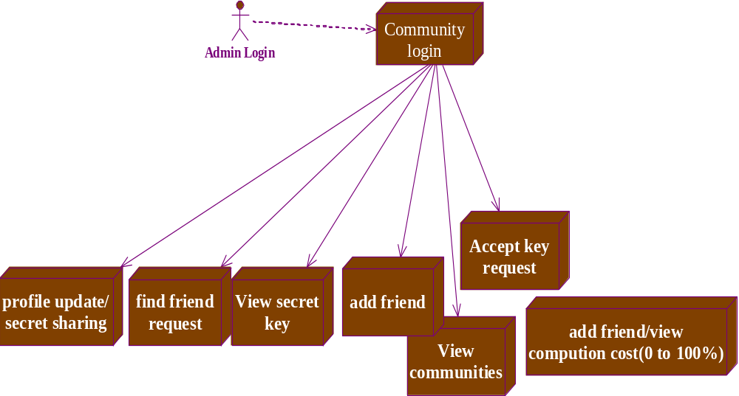

Group:

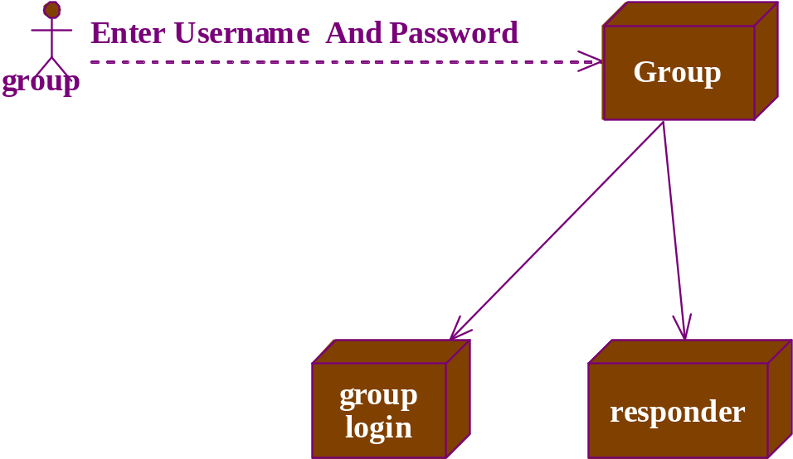

Admin:
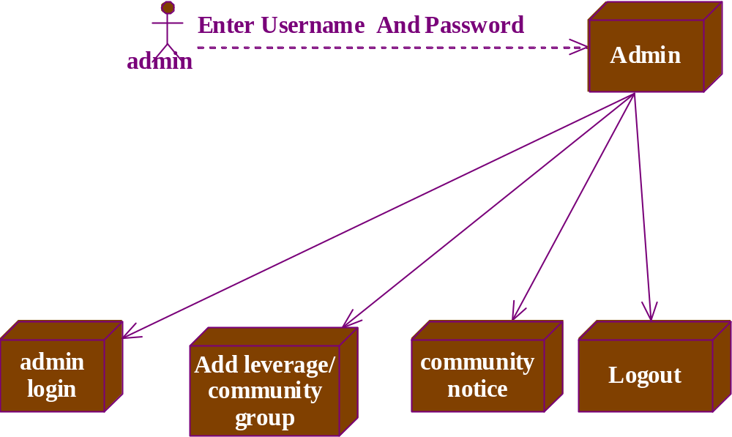

Use case Diagram:
(user:)
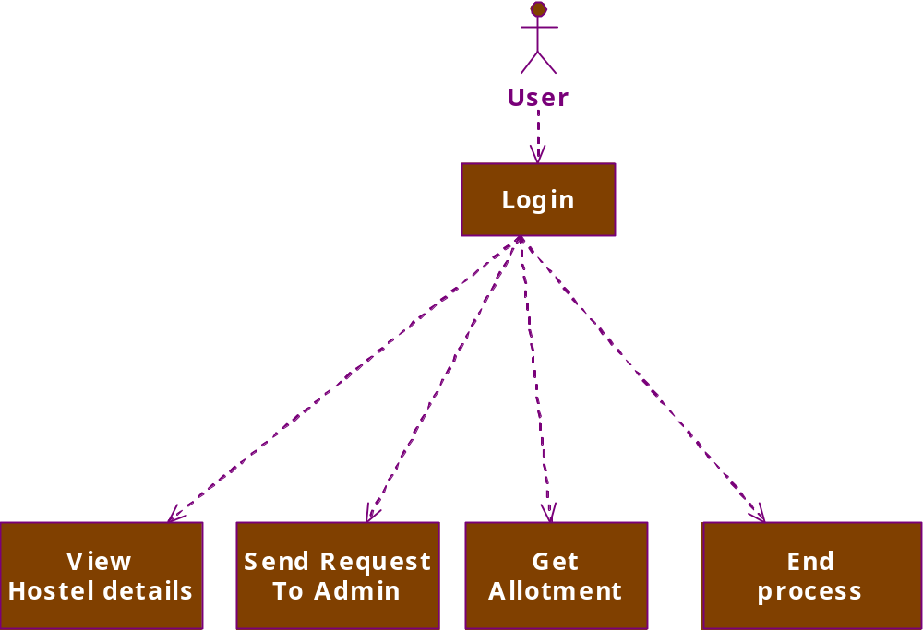

(Admin ):

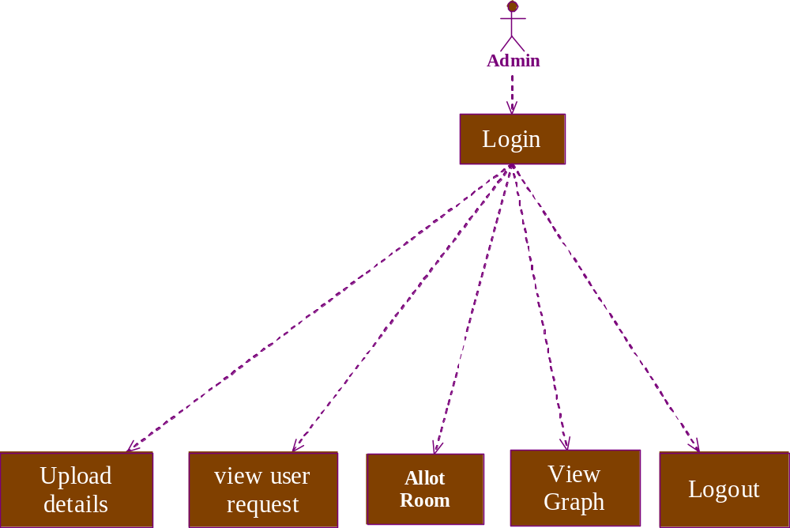

ACTIVITY DIAGRAM:
(user:)
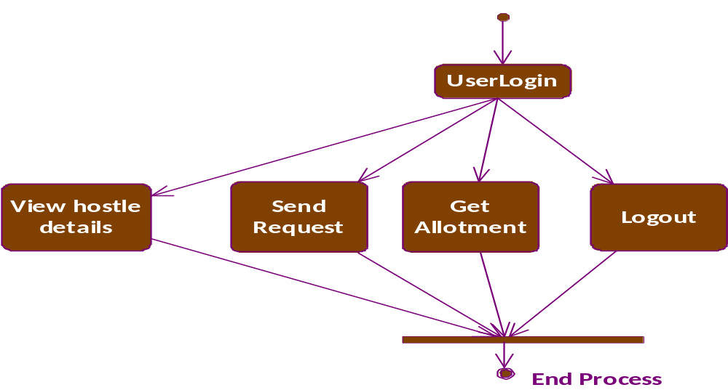

(Admin Login:)
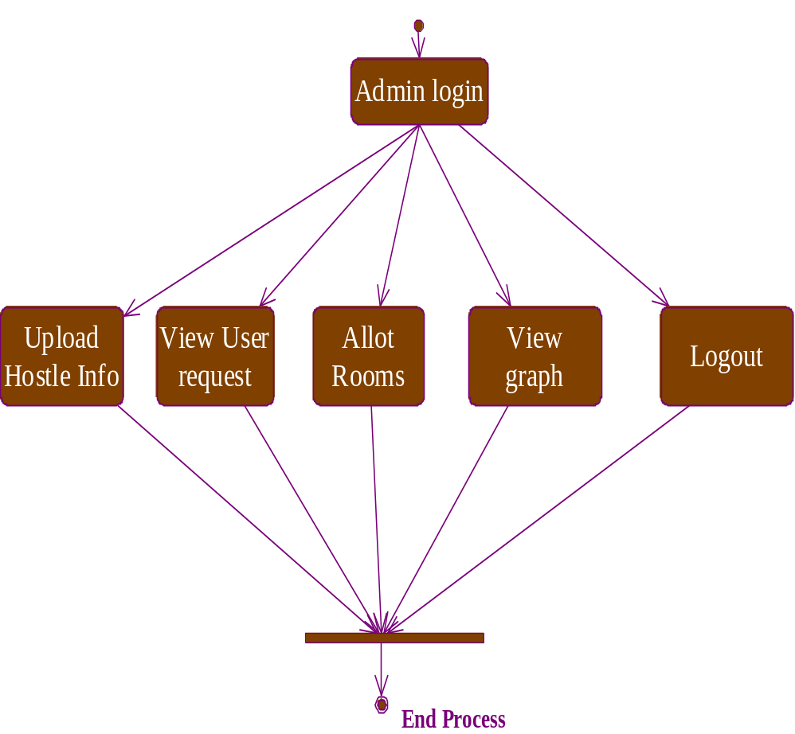

Sequence Diagram:

(User):
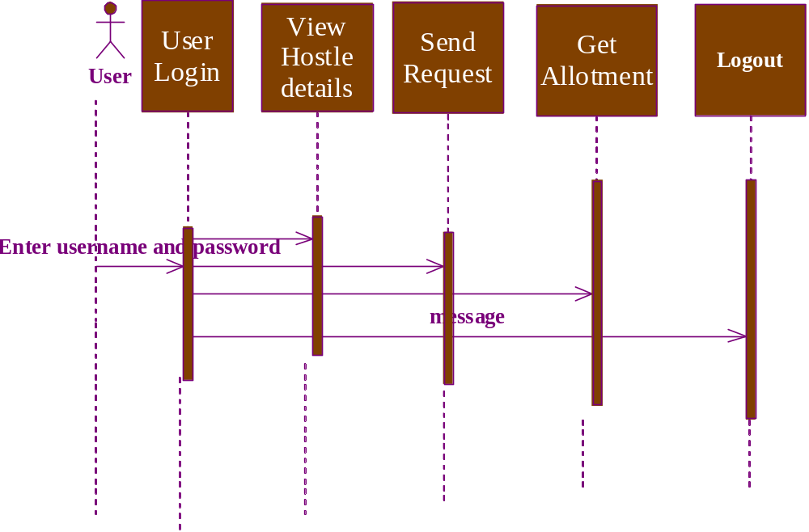

(Admin :)
